San Jose State University

EE250 (Section 2) Fall 2019 Prof. Kamali

Problem Set #8

- Problem 9.5
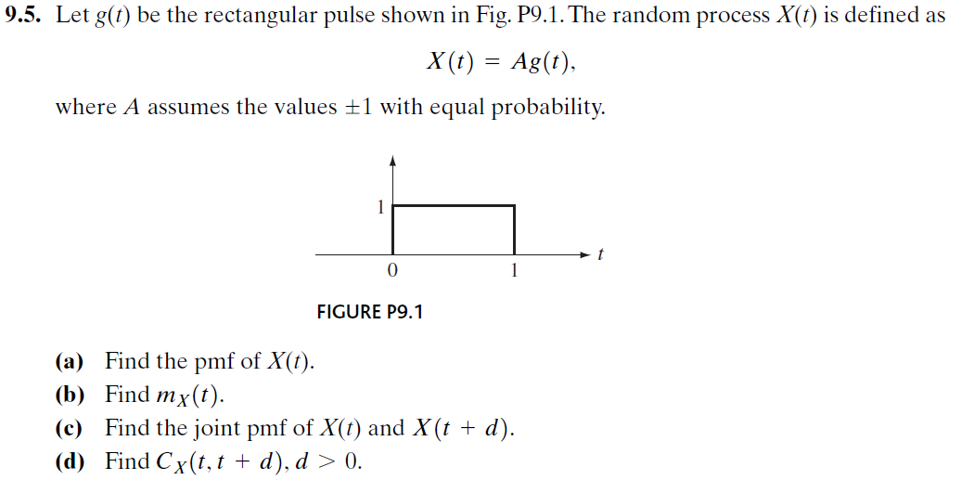

- Problem 9.26
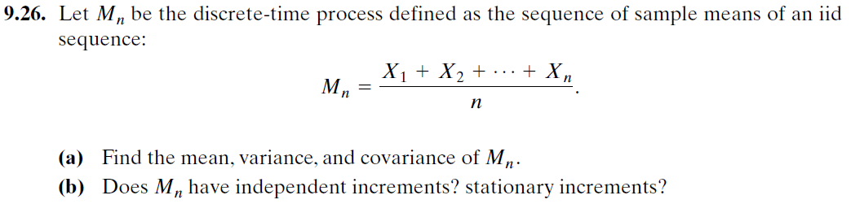

- [Final Exam, Spring 2008] The random process 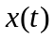is defined as follows where  and are two independent uniform random variables between 0 and 1 and 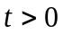.

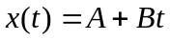

- Find and plot the pdf of (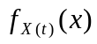).
- Find the range of where 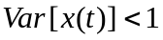.

- [Final exam, Spring 2014] Consider the random process 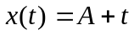 where is uniform in the interval [-1,1]. Find the pdf of 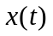.
- [Final Exam, Fall 2005] Suppose 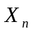 is an iid sequence where 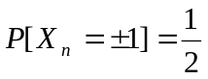. Find the mean and auto-covariance of 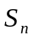defined as follows.

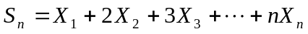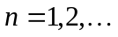

Hint: 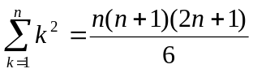

- [Final exam, Spring 2014] Consider the sum process 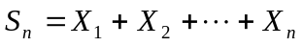 where 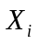's are iid and 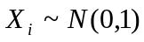 for 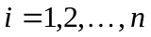. Find 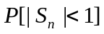.

You should write the answer in terms of Q function.

- [Final Exam, Fall 2009] Suppose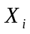’s are iid (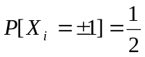 for 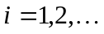) and 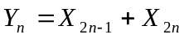 (). We define the discrete time random process as follows.

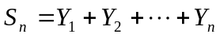

Find 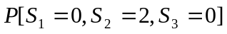.

- [Final Exam, Fall 2009] Suppose’s are iid with uniform pdf between 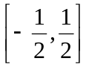 and

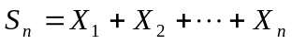

Find 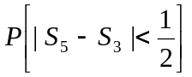.

- [Final exam, Fall 2015] Consider the discrete-time random process and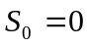 where 's are iid with Bernoulli distribution (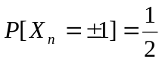). Find 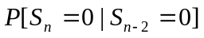.

Hint: 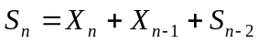

- [Midterm, Fall 2017] Assume  is an exponential random variable with mean 1 (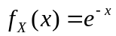for 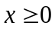) and 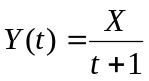 for 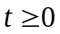. Find the pdf of 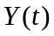.

- [Final exam, Fall 2017] Consider the discrete-time random process where 's are iid with Bernoulli distribution (). Find 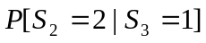.

Hint: 